**How the car moves in a path and what is required for it**

The car moves along a path by following a sequence of steps, which include turning to specific angles and moving forward for set distances. The function SetCarPath() is the core of this mechanism, where the car adjusts its yaw (turning angle) and controls its forward movement.

For example, the car was given an order to turn right at 90-degree angle and then move forward one meter with speed 150 for the path, the sequence will be as the following:

1. Turn to the Desired Angle:

* The car first turns to the desired angle (90-degree) using the turnCar(initial_angle, speedTurn) function.
* This ensures the car is facing the correct direction before moving forward.
* The yaw value from the MPU6050 sensor is continuously monitored, and the car adjusts its direction until the yaw matches the target angle (initial_angle).

1. Move Forward:

* Once the car is oriented correctly, it moves forward using the moveForward() function.
* The car will keep moving forward until it has covered the specified distance

(one meter).

Distance is calculated using an encoder (HC-020K). Each encoder step is counted, and the distance is computed as:

distance = (steps / 90.0) * 100;

* The motors’ speeds are adjusted dynamically to keep the car moving straight, based on the yaw angle:

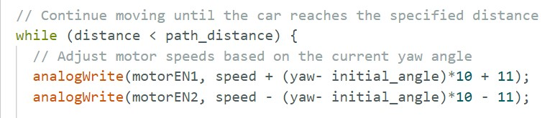

1. Stop After Covering Distance:

* When the car reaches the specified distance, it stops using the instantStop() function, which halts both motors.
* Detailed Breakdown of Path Movement:

The SetCarPath() function takes three parameters:

* initial_angle: the angle the car should turn to.
* path_distance: the distance the car should move forward after turning.
* speed: the speed at which the car should move.
* Step-by-Step Movement in a Path:
  1. Turn to Angle:
* The car starts by turning to the specified initial_angle using turnCar(). This function compares the current yaw with the desired yaw and adjusts the motor direction accordingly:
* If the car needs to turn right (i.e., the current yaw is greater than the target yaw), it calls moveRight().
* If the car needs to turn left, it calls moveLeft().
* Once the car reaches the target yaw, it stops and proceeds to move forward.
  1. Move Forward:
* After the turn is completed, the car moves forward using the moveForward() function. The motors are controlled such that the car travels straight.
* The distance the car travels is tracked by counting the encoder steps and converting those steps into distance.
  1. Adjust Speed to Stay on Path:
* During the forward movement, the car continuously checks its yaw angle to ensure it's moving straight along the path. If the car deviates from the desired angle:
* The speed of the left and right motors is adjusted to correct the direction, based on how far the yaw deviates from the initial angle.
  1. Stop at the Desired Distance:
* The car keeps moving forward until the total distance covered (tracked via encoder steps) matches path_distance. Once this condition is met, the car stops using the instantStop() function, bringing both motors to a halt.